Machine Learning
2º Lab Assignment

Shift: Thursday 17h | Group Number: 21
Number: 80966 | Name: Francisco Azevedo
Number: | Name: Duarte Dias

2 – The gradient descent method
2.1.1
η | a = 0.5 | a = 1 | a = 2 | a = 5
.001 | -1 | -1 | -1 | 990
.01 | 760 | 414 | 223 | 97
.03 | 252 | 137 | 73 | 31
.1 | 75 | 40 | 21 | 8
.3 | 24 | 12 | 5 | 8
1 | 6 | 1 | -1 | -1
3 | 6 | -1 | -1 | -1
Fastest
Divergence threslhold

2.1.2
We conclude that the parameters that grant the fastest convergence are the eta = 0.1 and a = 1.
For values of eta too high or too low the gradient does not converge.

2.1.3
For a = 0.5 the fastest optimization corresponds to 6 steps when eta = 1 or 3.
For a = 1 the fastest optimization corresponds to 1 step when eta = 1.
For a = 2 the fastest optimization corresponds to 5 steps when eta = 0.3.
For a = 5 the fastest optimization corresponds to 8 steps when eta = 0.3.
The value of eta that optimizes a differentiable function of one variable and for each given starting point in that number of steps is when eta = 1/a.
2.2.1
η | a = 2 | a = 20
.01 | 448 | 563
.03 | 148 | 196
.1 | 43 | -1
.3 | 13 | -1
1 | -1 | -1
3 | -1 | -1
Fastest | 13 | 196
Divergence threshold | η = 1 | η = 0.1

2.2.2
The function does not converge for learning rates etas with high values.
2.2.3
A narrower valley is associated to higher number of steps needed in order to converge to the desired function minimum (é o que diz o 3º paragrafo de 4.).

3.1
η | α = 0 | α = 0.5 | α = 0.7 | α = 0.9 | α = 0.95
.003 | -1 | -1 | -1 | -1 | -1
.01 | 563 | 558 | 552 | 516 | 448
.03 | 186 | 181 | 174 | 115 | 165
.1 | -1 | 48 | 35 | 91 | 122
.3 | -1 | -1 | 29 | 83 | 92
1 | -1 | -1 | -1 | 92 | 146
3 | -1 | -1 | -1 | -1 | 147
10 | -1 | -1 | -1 | -1 | -1
Div. Threshold | η= 0.1 | η = 0.3 | η = 1 | η = 3 | η = 10

3.2
The function will converge for a bigger range of different etas when the momentum term (alfa) is closer to 1 in value.

4.1
(corer script rosen4)
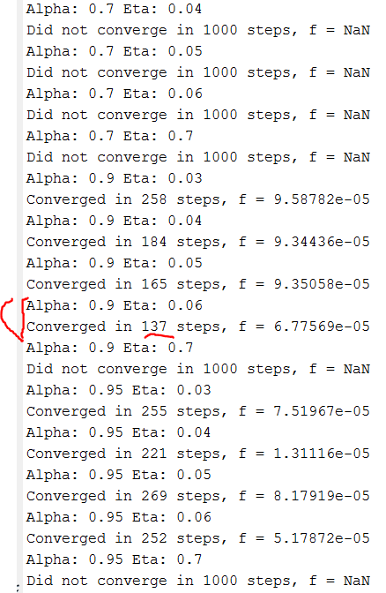
# of tests | alpha | η -> | -20% | -10% | best | +10% | +20%
143 | 0.95 | # of iterations -> | 153 | 159 | 137 | 147 | 146

Best at (eta = 0.06, alpha = 0.9))
4.2
In order to find the best alfa and eta association that results in the smallest number of steps we need to test for many different pairs of values. This was done using two nested for cycles running matrixes of different numbers for each variable. (Incomplete)
4.3
η | a = 0 | a = .5 | a = .7 | a = .9 | a = .95 | a = .99
.001 | 596 | 298 | 236 | 140 | 198 | 167
.01 | 565 | 287 | 221 | 190 | 200 | 165
.1 | 769 | 389 | 214 | 183 | 172 | 152
1 | 729 | 396 | 233 | 160 | 137 | 173
10 | 672 | 383 | 239 | 173 | 124 | 133

4.4
(script rosen44)
 | # of tests | η | alfa | # of iterations
Without | 90 | -10% | 0.9 | 722
Without | 90 | best | 0.9 | 637 (η = 0.0132)
Without | 90 | +10% | 0.9 | >1000
With | 90 | -10% | 0.99 | 312
With | 90 | best | 0.99 | 202 (η = 0.09)
With | 90 | +10% | 0.99 | 329
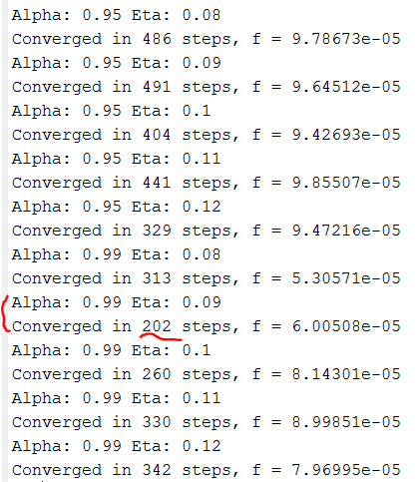

4.5
The function converges much faster when using adaptive step sizes.

